

**Restaurant website**

**Submitted by:**

ALISHETTI SHREE CHAKRA

**Registration No**: 12015952

Programme Name: B.Tech(CSE)

School of Computer Science & Engineering Lovely Professional University, Phagwara

**Student Declaration**

**To whom so ever it may concern**

I declare that this Assignment is my individual work. I have not copied it form any other students work or from any other source except where due acknowledgement is made explicitly in the text, nor has any part been written for me by any other person.

Name: ALISHETTI SHREE CHAKRA

**ACKNOWLEDGEMENT**

I would like to express my gratitude towards my University as well as my Professor **Dr. Manjot Kaur** for providing me the golden opportunity to do this wonderful work of website making and analyzing traffic, which also helped me in doing a lot of homework and learning. As a result, I came to know about so many new things. So, I am really thanks full to them.

Moreover, I would like to thank my friends who helped me a lot whenever I got stuck in some problem related to my course. I am really thankfull to have such a good support of them as they always have my back whenever I need.

Also, I would like to mention the support system and consideration of my parents who have always been there in my life to make me choose right thing and oppose the wrong. Without them I could never had learned and became a person who I am now.

I have taken efforts in this project. However, it would not have been possible without the kind support and help of many individuals and organizations. I would like to extend my sincere thanks to all of them.

**About the project:-**

I have designed a **yavinWebsite** in this project. This project is made with the help of HTML, CSS, JS and Bootstap

**HTML** stands for **Hyper Text Markup Language**. It is used to design web pages using markup language. HTML is the combination of Hypertext and Markup language. Hypertext defines the link between the web pages. Markup language is used to define the text document within tag which defines the structure of web pages.

C**ascading** S**tyle** S**heets**, fondly referred to as **CSS**, is a simply designed language intended to simplify the process of making web pages presentable. CSS allows you to apply styles to web pages. More importantly, CSS enables you to do this independent of the HTML that makes up each web page. It describes how a webpage should look: it prescribes colors, fonts, spacing, and much more. In short, you can make your website look however you want. CSS lets developers and designers define how it behaves, including how elements are positioned in the browser.

**JavaScript** is a dynamic computer programming language. It is lightweight and most commonly used as a part of web pages, whose implementations allow client- side script to interact with the user and make dynamic pages. It is an interpreted programming language with object-oriented capabilities.

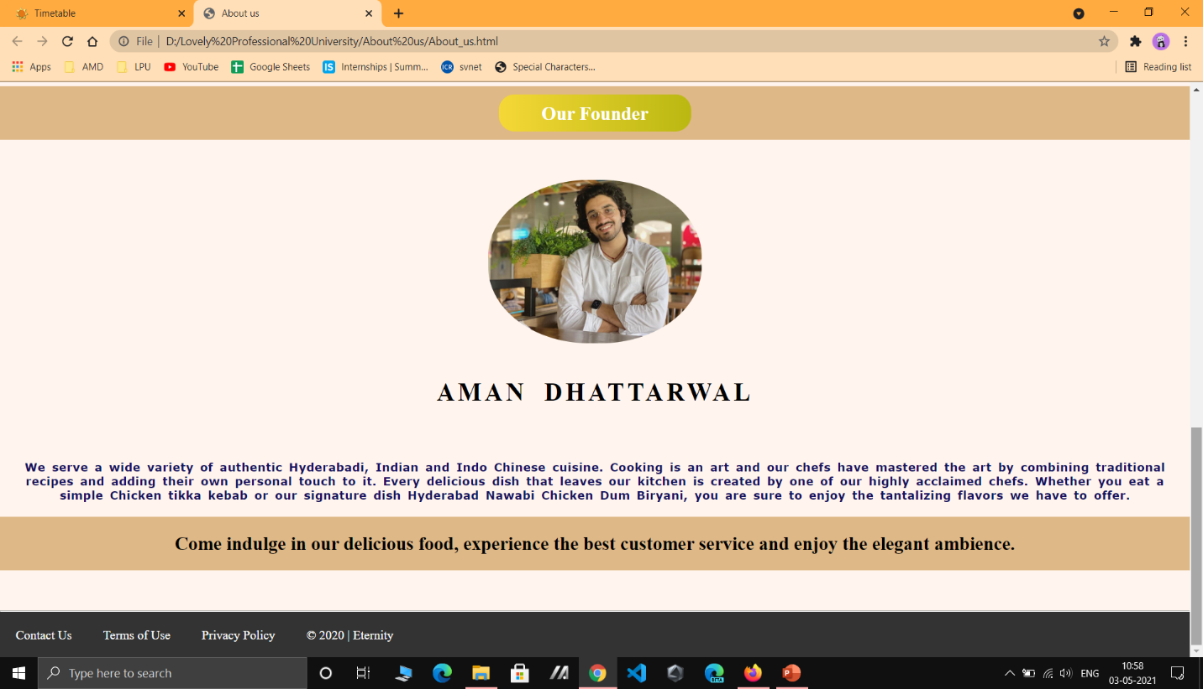

<!DOCTYPE html>

<html lang="en">

<head>

    <title>About us</title>

    <link rel="stylesheet" href="style.css">

</head>

<body>

    <nav>

        <a href="#">Home</a>

        <a href="#">Healthy Tips</a>

        <br>

    </nav>

    <main>

        <section>

            <br>

            <img src="Eternity.jpg" alt="logo">

            <br>

            <br>

            <h2>Our Story</h2><hr>

            <br>

            <h3> We give you a taste of Indian culture</h3>

            <br>

            <hr>

            <h1>ART OF FOOD</h1>

            <hr>

            <br>

            <h3>Welcome to Eternity Indian Cuisine</h3>

            <br>

           <video src="Restaurant food_Trim2.mp4" autoplay loop muted></video>

           <video src="videor.mp4" autoplay loop muted></video>

           <video src="Restaurant food_Trim.mp4" autoplay loop muted></video>

           <video src="Restaurant food_Trim_Trim.mp4" loop autoplay muted></video>

           <hr>

           <br>

            <p><em>India is a land of rich history and diverse cultures. Indian food reflects a perfect blend of this diversity and cultural influences. We at Eternity create delicious Indian food with authentic flavor, offering you the best of South and North Indian cuisine, a cuisine that has inspired the Culinary world.

                Eternity Biryanis isn't just about food, it is about our family and traditions.

                Come explore our various concepts that provide the Indian culinary experience.</em><hr>

            <br>

            <br>

            <br>

                <ul>

                    <b>

                   <li>&#9830 ETERNITY INDIAN CUISINE</li>

                   <li>&#9830 ETERNITY BIRYANIS</li>

                    <li>&#9830 ETERNITY SWAGRUHA</li>

                    <li>&#9830 ETERNITY BIRYANIS AND BAKERY (HOT BREADS)</li>

                    <li>&#9830 ETERNITY AND MORE</li>

                </b>

                </ul>

                <br>

            </p>

        </section>

        <section>

       <h5>The food you love...The Tradition we follow... We welcome you to indulge in our traditional creations....</h5>

       <br>

       <br>

       <h2><span>Our Founder</span></h2>

       <img class="profile" src="aman.jpg" alt="Our Founder">

       <br>

       <br>

       <h3 class="profile_name">Aman Dhattarwal</h3>

       <br>

       <br>

       <h5 class="about_content">We serve a wide variety of authentic Hyderabadi, Indian and Indo Chinese cuisine. Cooking is an art and our chefs have mastered the art by combining traditional recipes and adding their own personal touch to it. Every delicious dish that leaves our kitchen is created by one of our highly acclaimed chefs. Whether you eat a simple Chicken tikka kebab or our signature dish Hyderabad Nawabi Chicken Dum Biryani, you are sure to enjoy the tantalizing flavors we have to offer.</h5>

           <br>

            <h2>Come indulge in our delicious food, experience the best customer service and enjoy the elegant ambience.</h2><hr>

        </section>

        </main>

    <footer>

        <a href="#">Contact Us</a>

        <a href="https://www.g2.com/static/terms">Terms of Use</a>

        <a href="https://www.g2.com/static/privacy">Privacy Policy</a>

        <a href="https://www.google.com/url?sa=t&rct=j&q=&esrc=s&source=web&cd=&ved=2ahUKEwjJmoSNiZXwAhX2yjgGHZBsAGIQFjAAegQIBRAD&url=https%3A%2F%2Fcopyright.gov.in%2F&usg=AOvVaw0MB4CB_UkXDQ8bAnwlRr0E">&copy; 2020 | Eternity</a>

    </footer>

</body>

</html>

CSS:

* {

*box-sizing*: border-box;

*padding*: 0;

*margin*: 0;

  }

  nav {

*background-color*: #333;

*overflow*: hidden;

}

 h1 {

*text-align*: center;

*font-size*: 40px;

*font-family*: Impact, Haettenschweiler, 'Arial Narrow Bold', sans-serif;

}

h3{

*font-size*: 25px;

}

img {

*width*:17%;

*border-radius*: 50%;

}

em{

*font-size*: 20px;

}

ul{

*font-size*: 17px;

}

video{

*width*: 24%;

}

li{

*text-align*: left;

}

h5{

*font-size*: 90%;

*text-align*: center;

*font-family*:Verdana, Geneva, Tahoma, sans-serif;

*word-spacing*: 3px;

*letter-spacing*: 0.4px;

*padding*: 0px 10px;

*color*: #120f5e;

}

nav a {

*text-decoration*: none;

*padding*: 20px;

*text-align*: center;

*float*: left;

*color*: white;

}

main {

*background-color*: seashell;

*text-align*: center;

}

h2 {

*padding*: 20px;

*background-color*: burlywood;

*margin-bottom*: 50px;

}

 h2 span {

*padding*: 10px 55px;

*border-radius*: 20px;

*color*: #fff;

*background*: linear-gradient(to right, #f5d837, #bbb812);

}

.profile {

*width*: 18%;

*border-radius*:47%;

}

.profile_name {

*font-size*: 2em;

*font-weight*: 900;

*letter-spacing*: 4px;

*word-spacing*: 10px;

*text-transform*: uppercase;

*margin*: 20px 0px 30px 0px;

  }

footer {

*background-color*: #333;

*overflow*: hidden;

}

footer a {

*text-decoration*: none;

*padding*: 20px;

*text-align*: center;

*float*: left;

*color*: white;

}